

This description gives a brief overview as to the contents of this document.

**Version: 1.0**

**Published: 8 September 2016**

Table of Contents

1 Introduction 3

2 Login In 4

3 Home Page 6

3.1 Bar Chart 8

3.2 Line Chart 10

3.3 Transactions Settled Status’ 11

4 Reveal Menu 14

4.1 Open and close the menu 14

4.2 Change the displayed page 14

5 Search page 15

5.1 Search 16

5.2 Filters 17

5.3 Sorts 19

6 Results page 20

6.1 Changing Sorts 20

6.2 Detailed Result View 21

7 Settings page 23

8 Contact Us page 24

8.1 Email 24

8.2 Call 26

8.3 Copy 27

9 Log Out page 28

10 Further Information and Support 29

10.1 Secure Trading Support 29

10.2 Secure Trading Sales 29

10.3 Useful Documents 29

10.4 Frequently Asked Questions 29

# Introduction

MyST Portal gives the MyST experience on an iOS device. MyST is a password protected area which allows all Secure Trading merchants to process transactions.

It is located on the iOS App Store as “MyST Portal”.

When you open a Secure Trading account you will be issued with a MyST login comprising a username (a valid email address) and password. You will also be advised of your sitereference. A sitereference is a unique code which identifies your account in our system.

If you experience any problems using MyST, please contact our Support team – contact details can be found in section **11** **Further Information and Support.**

|  |  |
| --- | --- |
| C:\Users\mb0137\Documents\FINAL ST ICONS\ST Support Icons-03.png | To use this app you must be using a iOS device running on iOS 9 or later. |

# Login In

Before you can use MyST iOS App you must first securely log in.

The first page you will see when you open the app is the login screen as shown below:

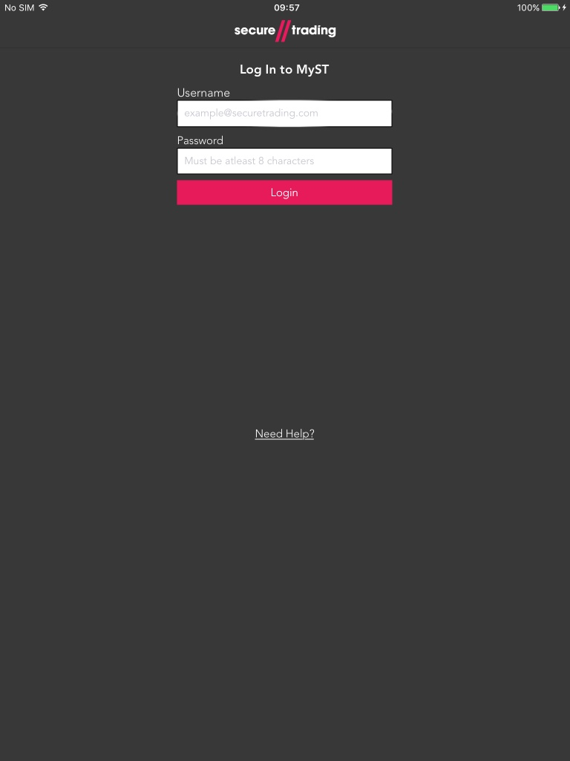

Figure 1 – Login page

|  |  |
| --- | --- |
| C:\Users\mb0137\Documents\FINAL ST ICONS\ST Support Icons-03.png | The ‘Need Help?’ button when press navigates to the Contact Us page.  This will be covered in section 8 **- Contact Us page.** |

Enter your username and password in the boxes provided and click the “Login” button.

Alternatively, you can switch from the first box to the next by pressing “Next” on the keyboard then press “Go” to login as shown below:

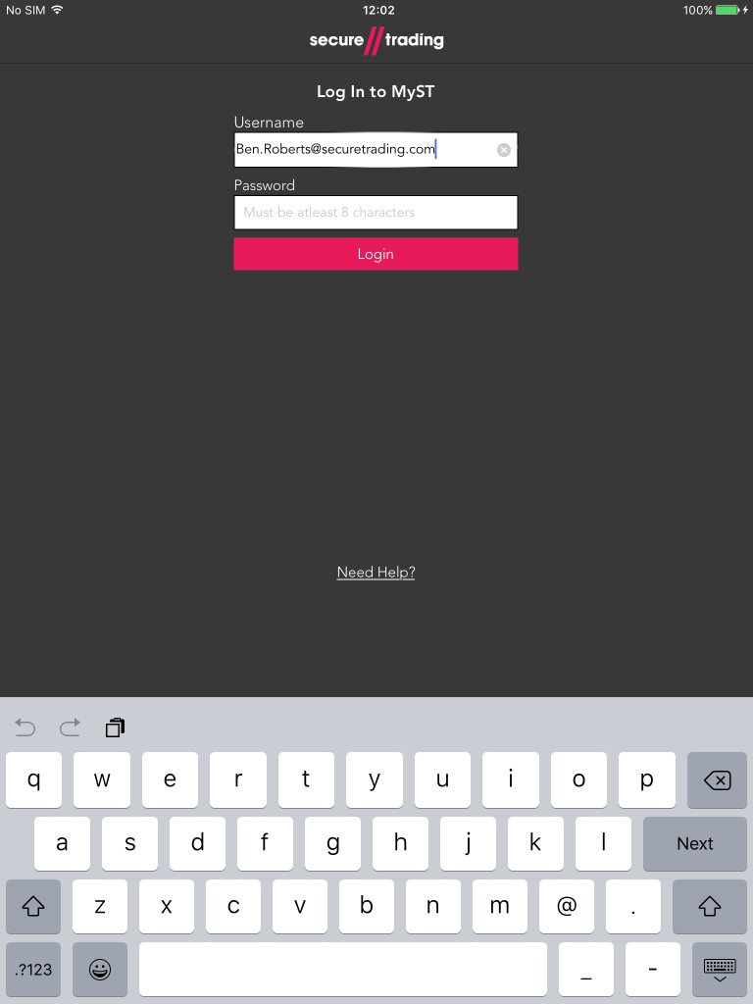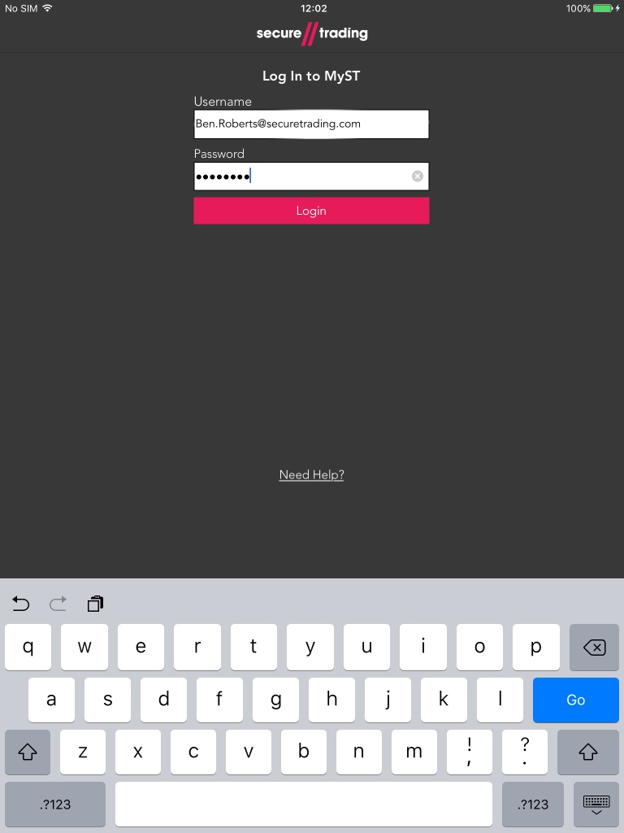

Figure 2 – Keyboard ‘Next’ button Figure 3 – Keyboard ‘Go’ button

|  |  |
| --- | --- |
| C:\Users\mb0137\Documents\FINAL ST ICONS\ST Support Icons-03.png | **Please note** that passwords are case sensitive |

If you are unable to log in, contact your MyST Site-Admin user. If you do not know who this is, contact our Support team (see section **11** **Further Information and Support**)

# Home Page

The homepage displays transactions textually broken down into 4 sections:

* Total – This displays all transactions.
* Past 24 Hours – This displays all transactions occurred today.
* Past 6 Days – This displays all transactions occurred in the past six days.
* Past 30 Days – This displays all transaction occurred in the past thirty days.

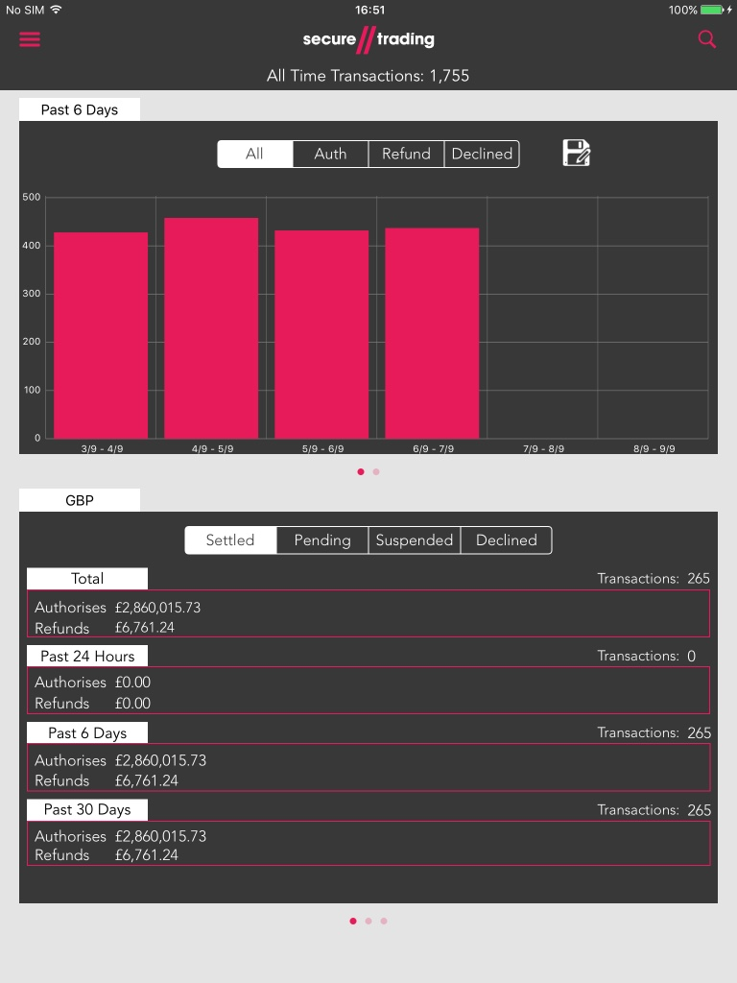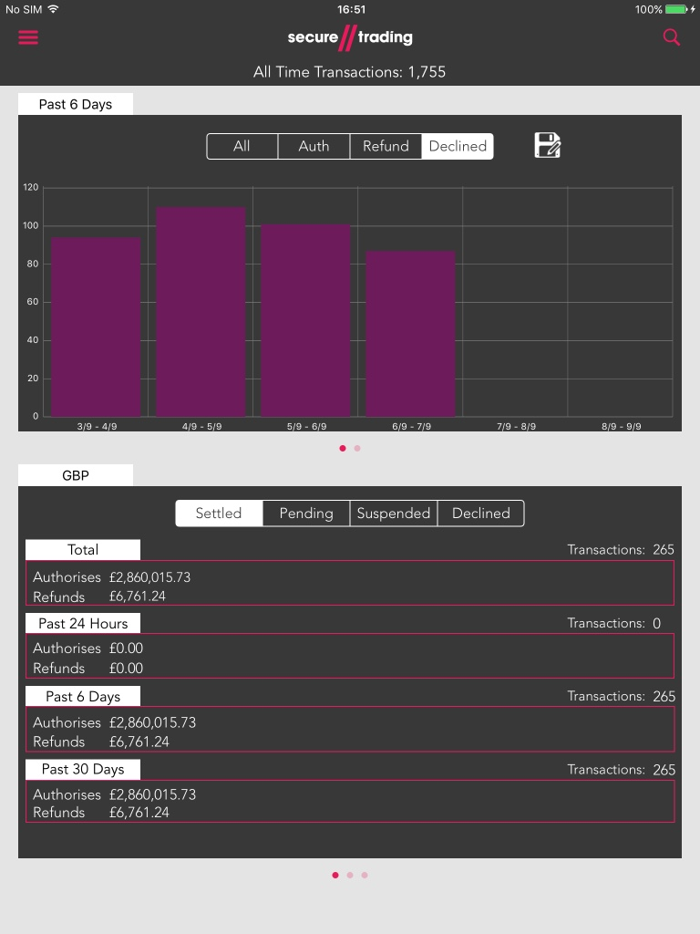

Figure 4 – Bar Chart: All Transactions Figure 5 – Bar Chart: Refund Transactions

The homepage also displays transactions graphically broken down into 2 sections:

* Bar Chart – This chart has the option to display four different types of transactions: authorized, refunded, declined and all types in the past 6/12/30/60 days.
* Line Chart – This chart displays both authorized, refunded and declined transactions alongside each other in the past six months.

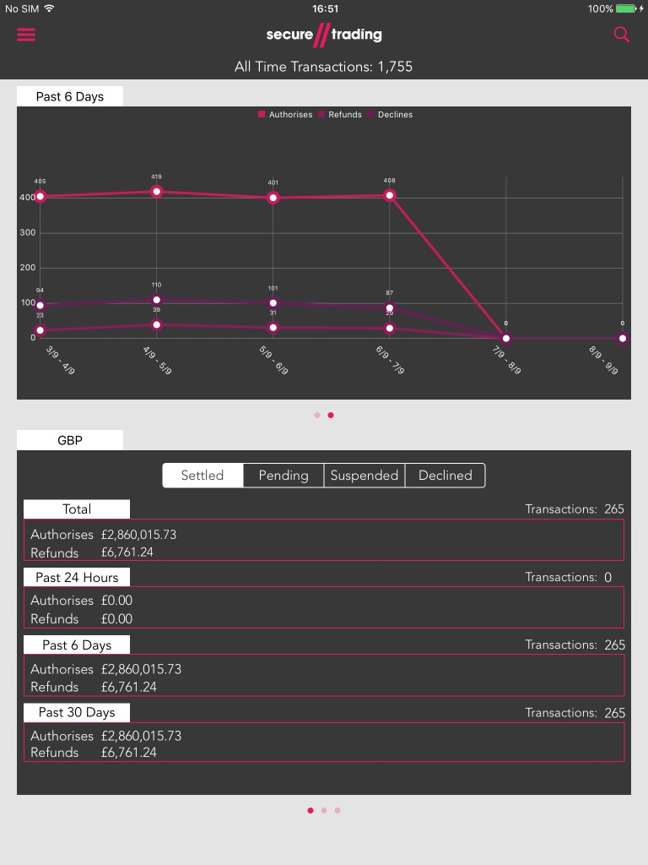

Figure 6 – Line Chart: Auth, Refund and Decline comparison

|  |  |
| --- | --- |
| C:\Users\mb0137\Documents\FINAL ST ICONS\ST Support Icons-03.png | The timeframe for the graph can be changed by pressing the ‘Past ‘x’ Days’ button above the graph and selecting one of the options in the menu. |

## Bar Chart

### Change chart types



Figure 7 – Bar Chart: All Transactions

To switch between the four different types of charts, select one of the four options within the segmented control white being the current selected as shown in the figure above with ‘All’ being selected.

The ‘All’ segment show all types of transactions e.g. Auth, Refund and Decline. Auth displays all authorised transactions; refund displays all refunded transactions and decline displays all declined transactions.

### Breakdown of transactions for Bar Graph

A functionality that the bar chart has, is being able to select a specific bar and being able to see what account, currency or payment type each transaction is within the selected bar.

To get a breakdown of a specific bar, tap on a bar within the chart. Depending on whether the application is being ran on an iPad or not it will display a popover view or a page respectively as shown below:

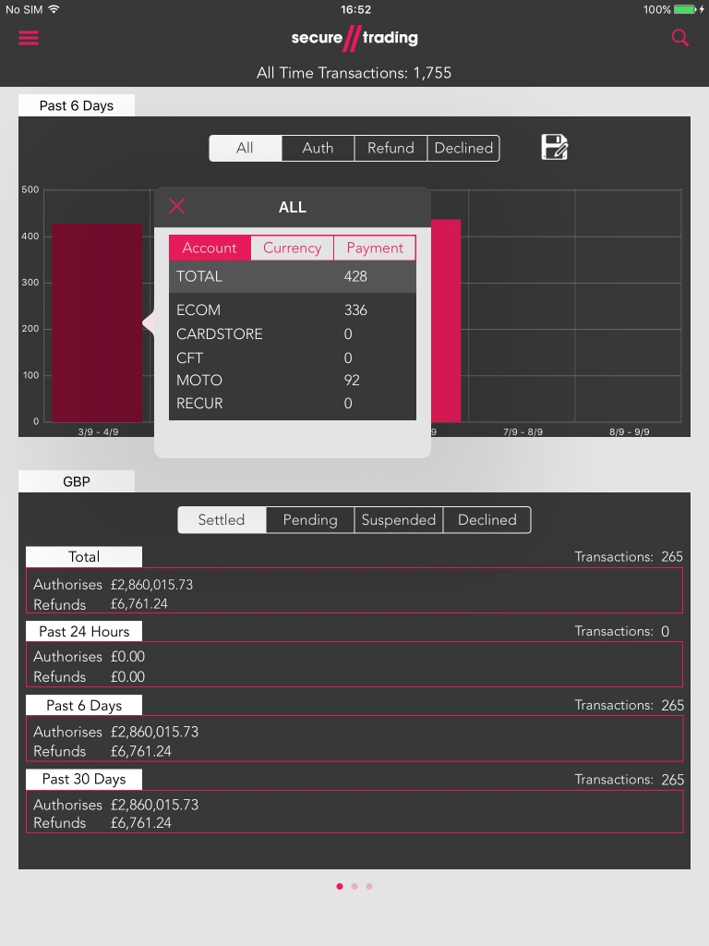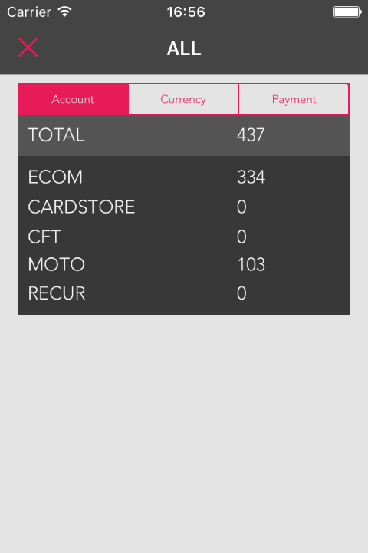

|  |  |
| --- | --- |
| C:\Users\mb0137\Documents\FINAL ST ICONS\ST Support Icons-03.png | To return to the homepage press the ‘Dismiss’ button.  Alternatively, on the iPad, press anywhere outside the small view. |

Figure 8 – iPad: Graph Breakdown view Figure 9 – iDevice: Graph Breakdown view

### Breakdown as a specific type

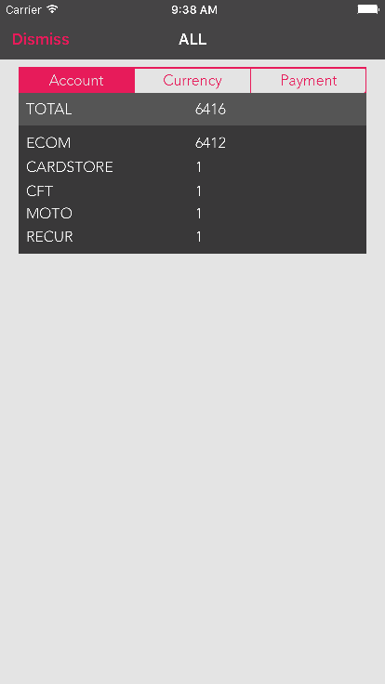

Figure 10 – Segmented Control: Account Selected

The type of information that is displayed in the breakdown is dependent on which segment is selected.

In the above figure, ‘Account’ is selected as it is colour in red. For example, to see a breakdown of the currency types within the bar, select the ‘Currency’ segment.

Account segment displays all account types e.g. ECOM MOTO and RECUR.

Currency segment displays all currency types e.g. GBP, USD and EURO.

Payment segment displays all payment types e.g. VISA, MASTERCARD and PayPal

### Save Graph

To save the graph tap the floppy disk icon and an action sheet will appear as shown below:

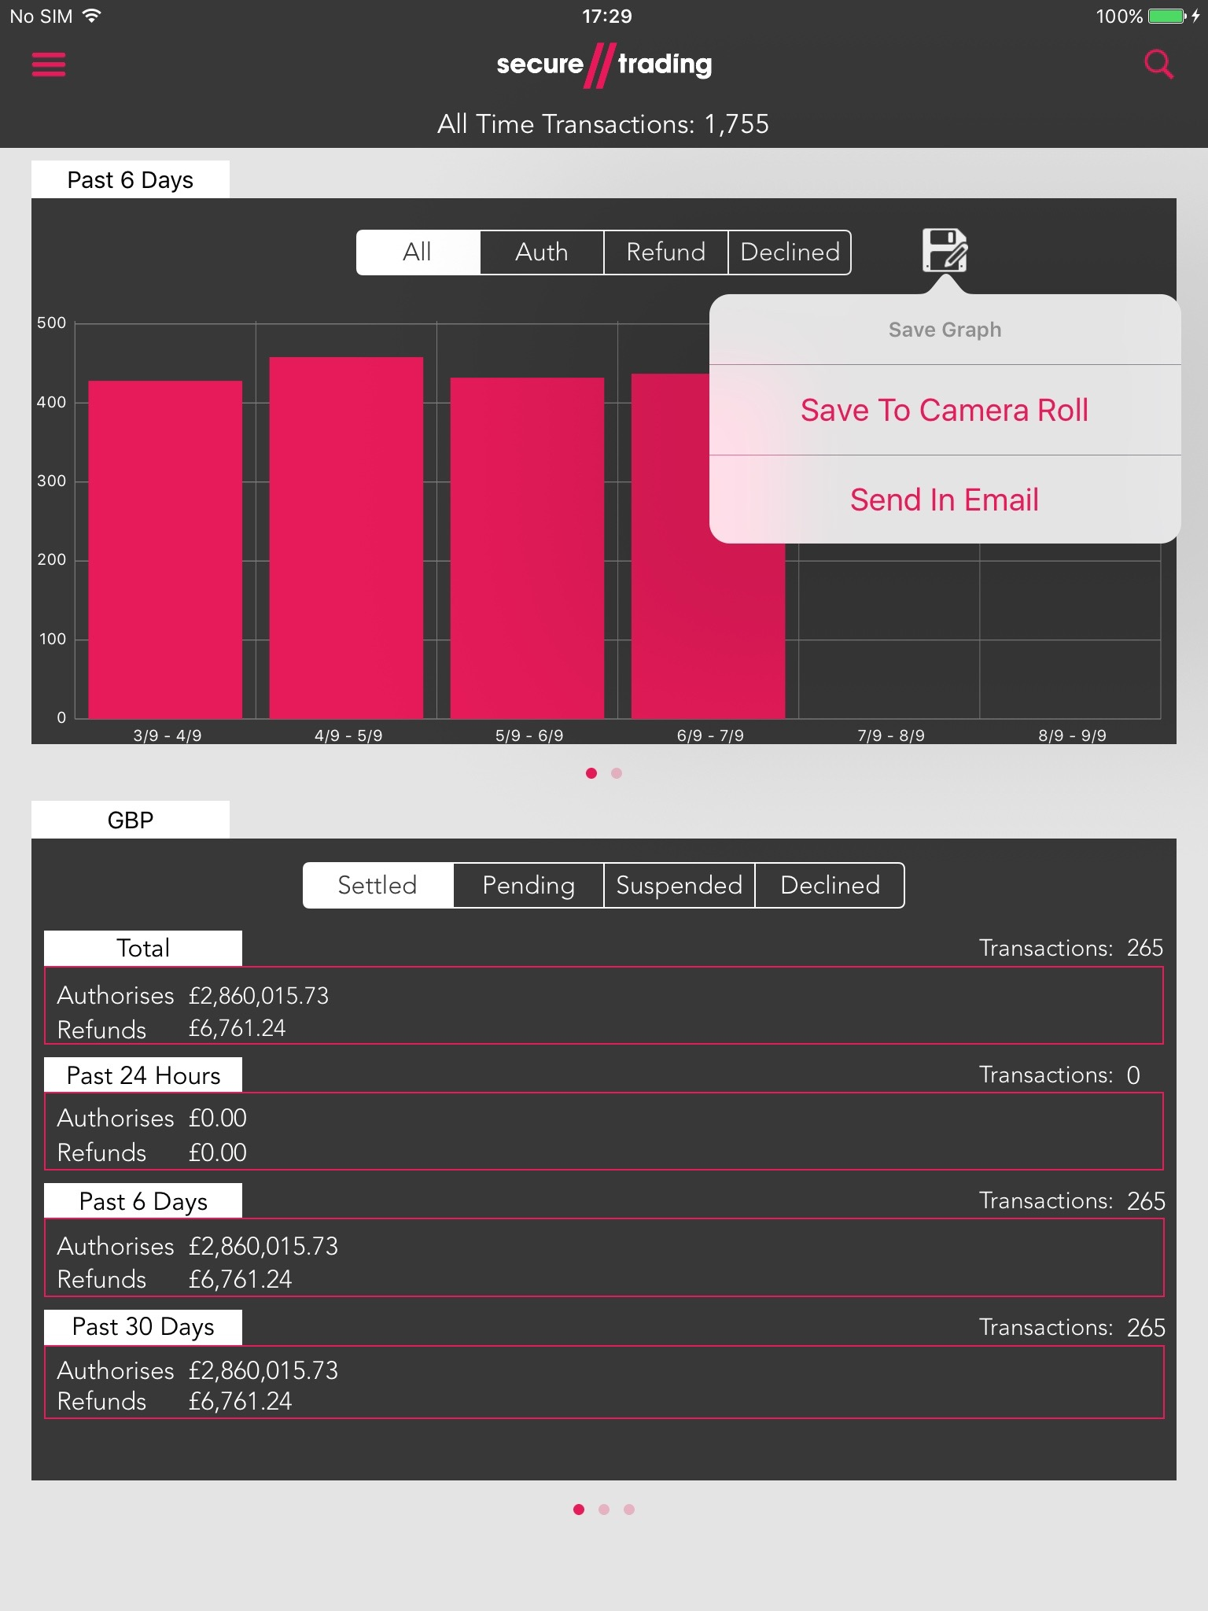

**Figure 11 – Save Graph Actionsheet**

To just save the image to your camera roll tap “Save To Camera Roll” otherwise tap “Send In Email” to send the graph as an image in an E-Mail as shown below:

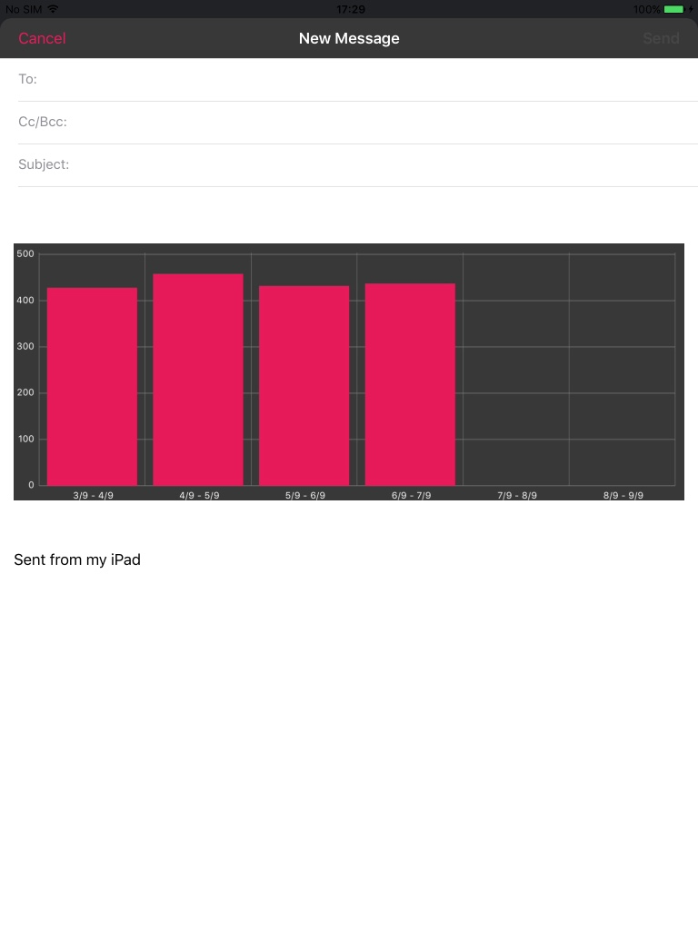

**Figure 12 – Graph in Email**

## Line Chart

### Switching from Bar Chart to Line Chart

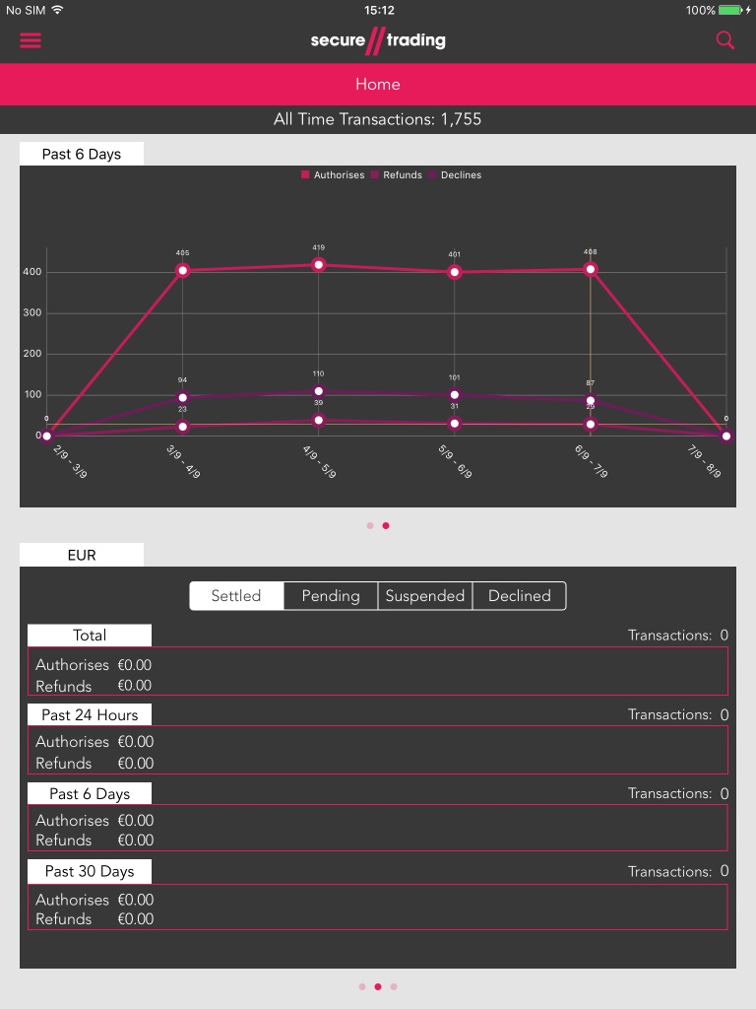

**Figure 13 – Bar Chart** **Figure 14 – Line Chart**

To switch from bar chart to line chart, make a sliding gesture from right to left in the chart which will drag out the line chart.

|  |  |
| --- | --- |
| C:\Users\mb0137\Documents\FINAL ST ICONS\ST Support Icons-03.png | To return to the bar chart, make a sliding gesture from left to right in the chart. |

### Breakdown of transactions for Line Graph

To get a breakdown of a specific point, tap on a point within the chart. Depending on whether the application is being ran on an iPad or not it will display a popover view or a page respectively as shown below:

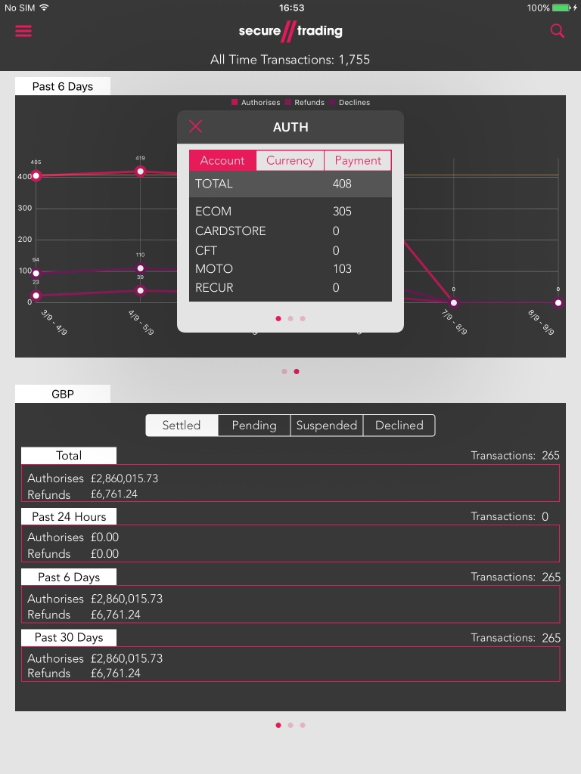

**Figure 15 – Line Graph breakdown**

To switch between the three types of points within that given time frame preform a slide gesture

e.g. if Auth point between 00:00am – 02:00am is selected, a slide gesture would then display Refund within the same timeframe.

## Transactions Settled Status’

### Displaying different transaction settled status’

To display different types selected one of the four segments either: Settled, Pending, Suspended or Declined. This will display the respective transactions.

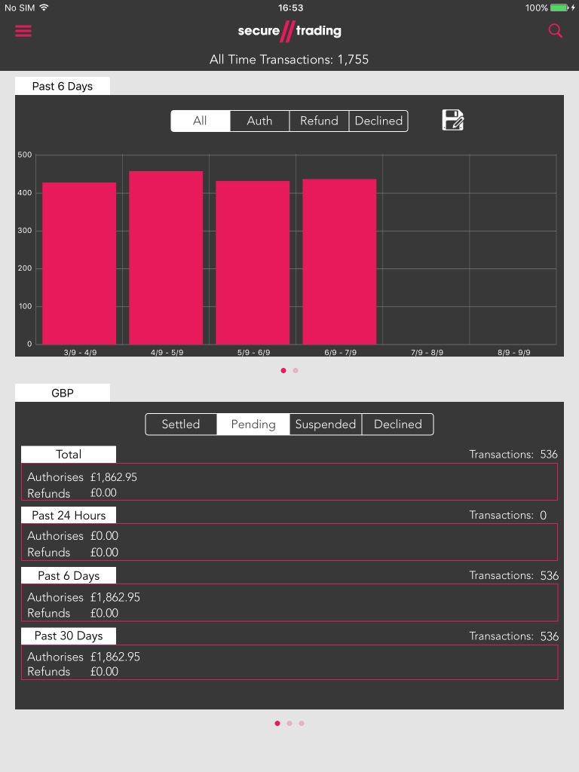

**Figure 16 – Displaying Different Settled Status Transactions**

### Change Currency Displayed

To change the currency being displayed in the view tap the currency type header at the top and selected the desire currency type as shown below:

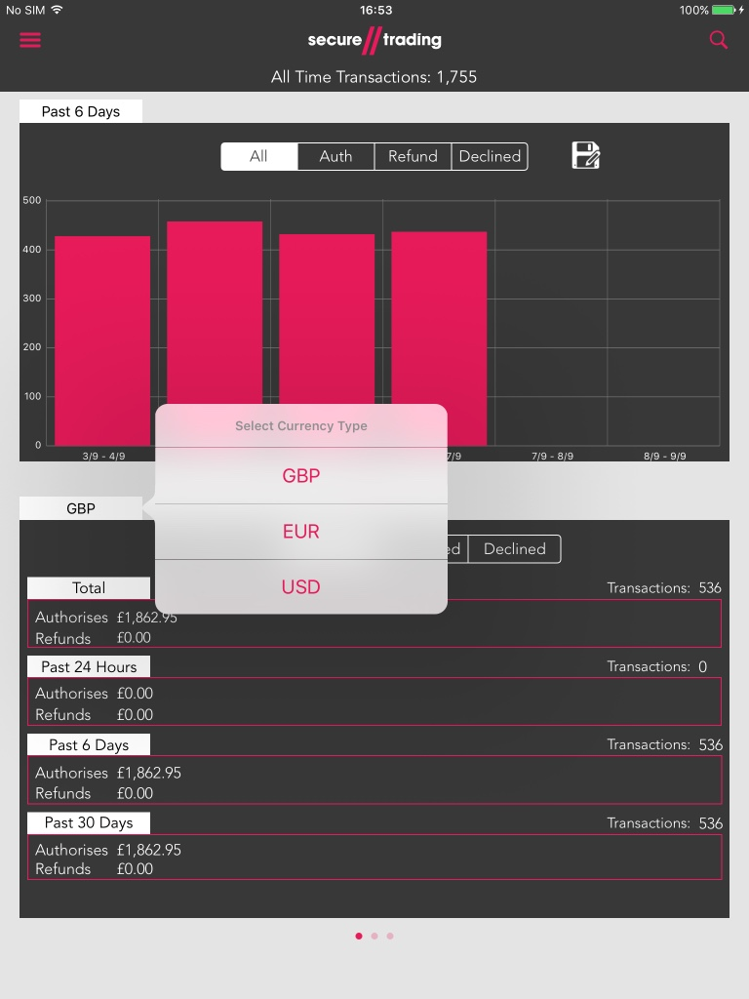

**Figure 17 – Choose Currency Type Displayed**

|  |  |
| --- | --- |
| C:\Users\mb0137\Documents\FINAL ST ICONS\ST Support Icons-03.png | Alternatively, make a slide gesture within the view and another currency type shall be displayed. |

### Displaying A Bar Graph For A Timeframe

To display a graph for a given timeframe, tap on the header for that respective timeframe e.g. Total, Past 24 Hours, Past 6 Days or Past 30 Days. This will cause a popover or an alert sheet to appear as shown below:

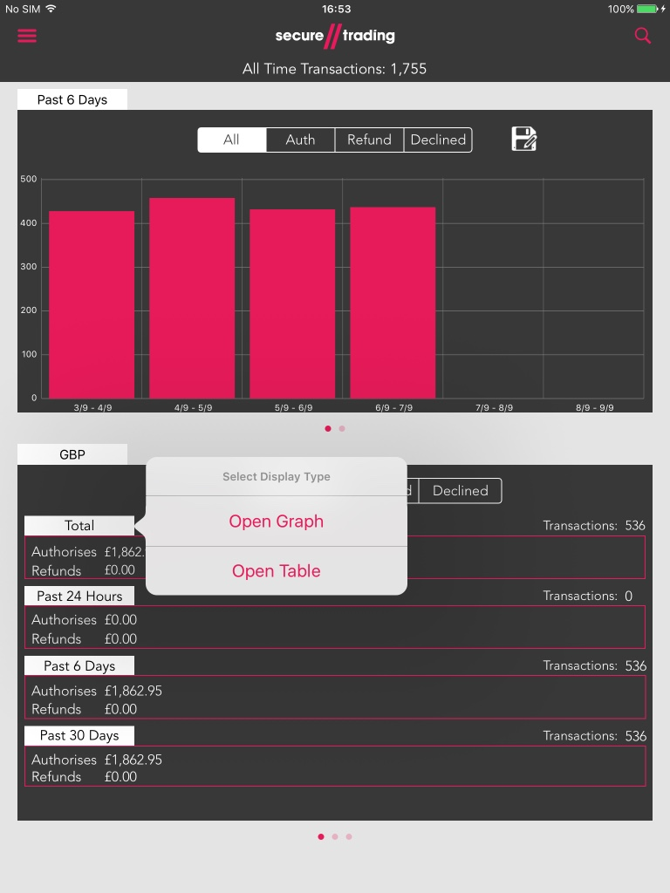

**Figure 18 – iPad: Open Graph/Table Popover**

Next, press ‘Open Graph’ and a graph will appear with the data for that timeframe.

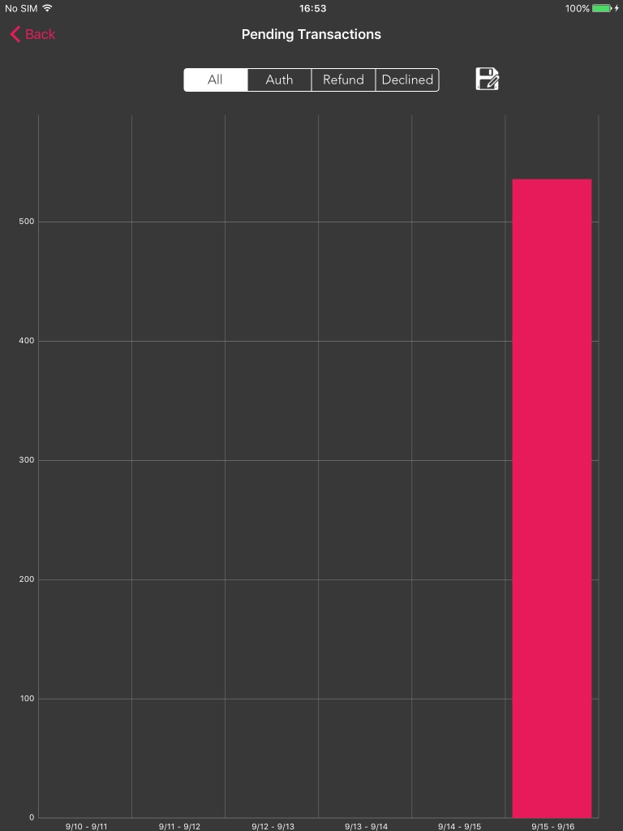

**Figure 19 – Open Graph View**

### Displaying A Table For A Timeframe

Like the previous section press on the desired timeframe header and a popover/alert sheet will appear. Press ‘Open Table’ and a table will appear with the data for that time frame as shown below:

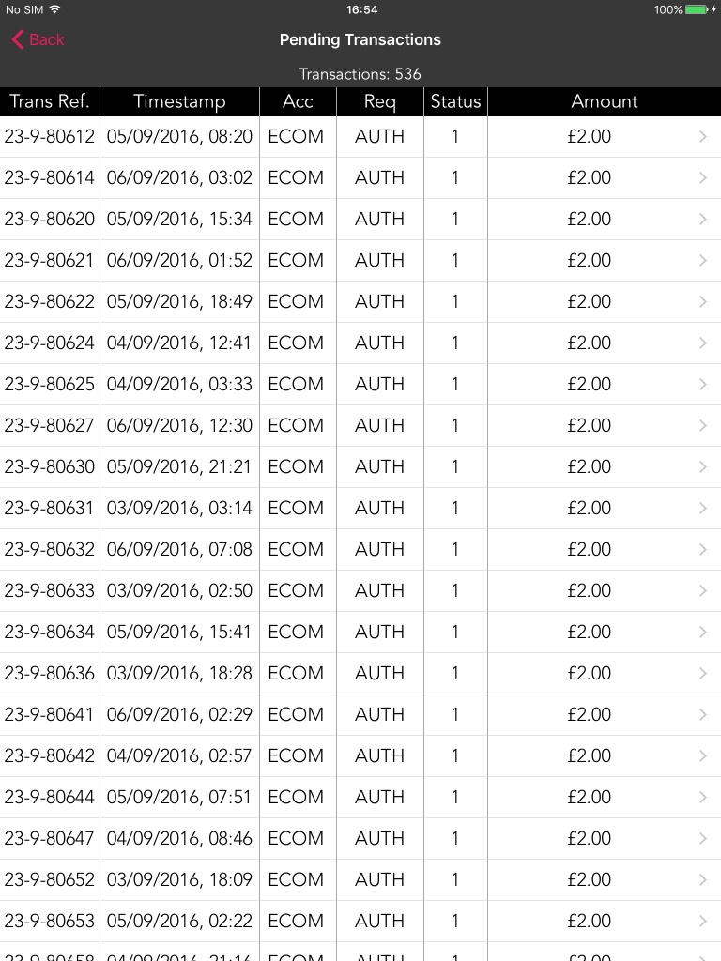

**Figure 20 – Open Table View**

|  |  |
| --- | --- |
| C:\Users\mb0137\Documents\FINAL ST ICONS\ST Support Icons-03.png | Refer to section **6.2** on how to display more details on a single transaction. |

# Reveal Menu

## Open and close the menu

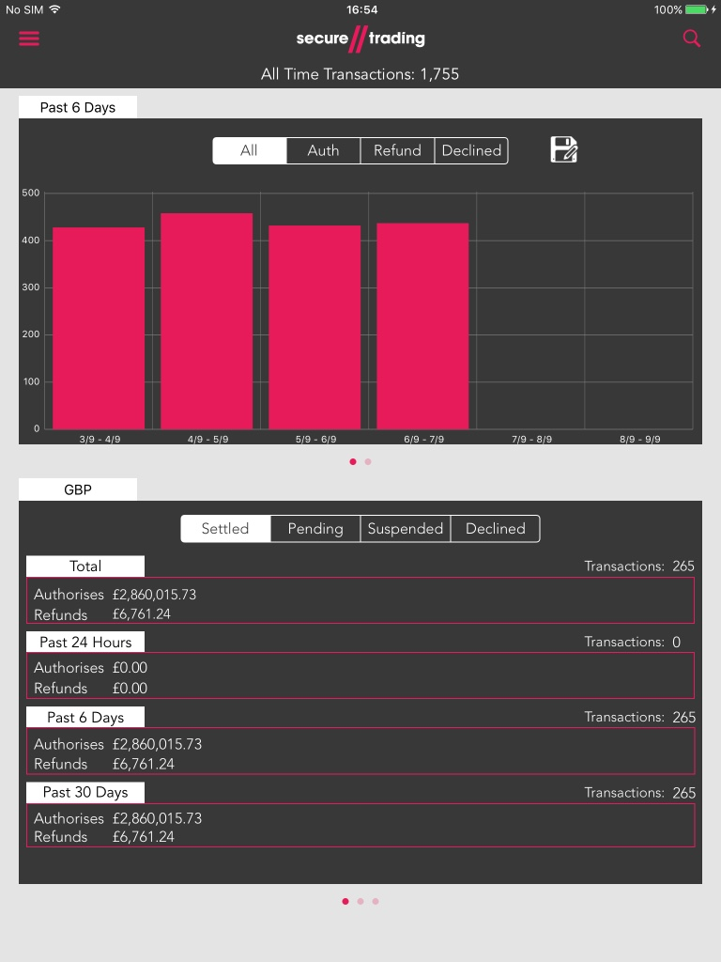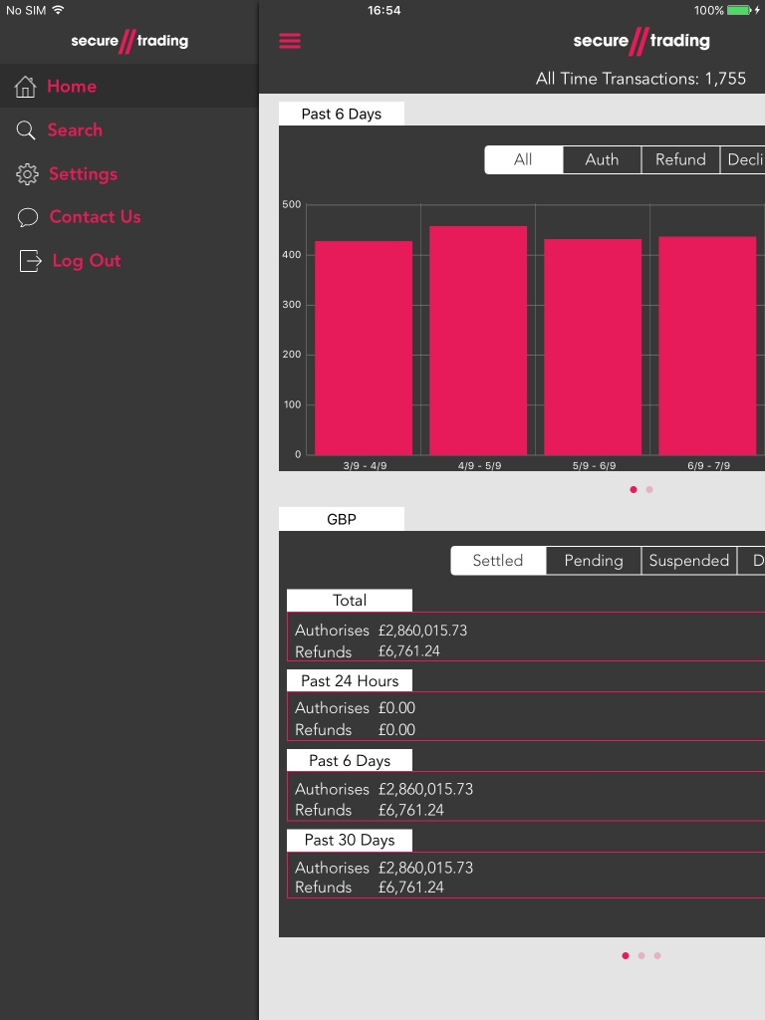

**Figure 21 – Unrevealed Figure 22 – Revealed**

To open the reveal menu, you can either tap the icon on the top left or make a slide gesture from left to right anywhere on the screen expect within the chart.

To close the reveal menu, you can either tap the icon on the top, make a slide gesture from right to left anywhere on the screen expect within the chart, or tap the main page.

## Change the displayed page

After the menu has been revealed, as show in figure 14, select the desired page in the menu e.g. tap ‘Search’ and it will transition to that page.

|  |  |
| --- | --- |
| C:\Users\mb0137\Documents\FINAL ST ICONS\ST Support Icons-03.png | It’s also possible to transition to the ‘Search’ page from the Homepage by pressing the search icon at the top right of the screen as shown in figure 13. |

# Search page

Navigate to the search page through the use of the reveal menu - details can be found in section **4** **Reveal Menu.**  If done correctly the below page should appear:

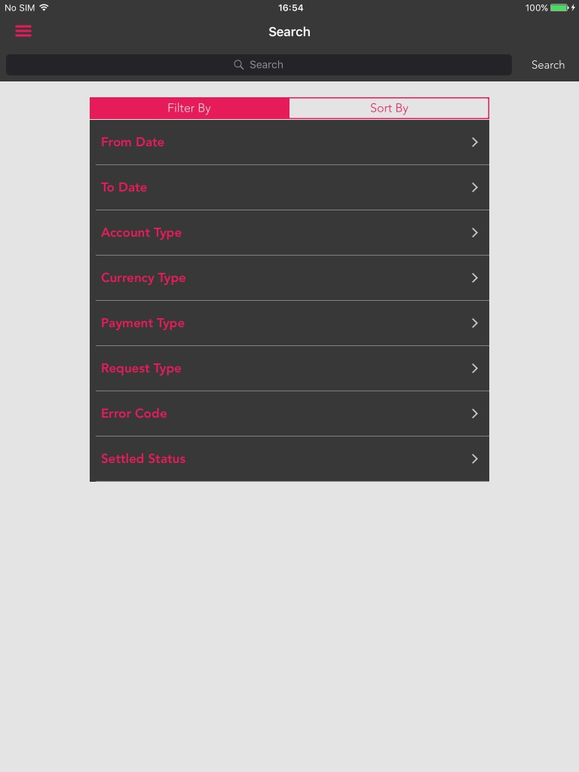

**Figure 23 – Search page**

## Search

To preform a search, tap on the search bar at the top of the screen as the keyboard will appear as shown below:

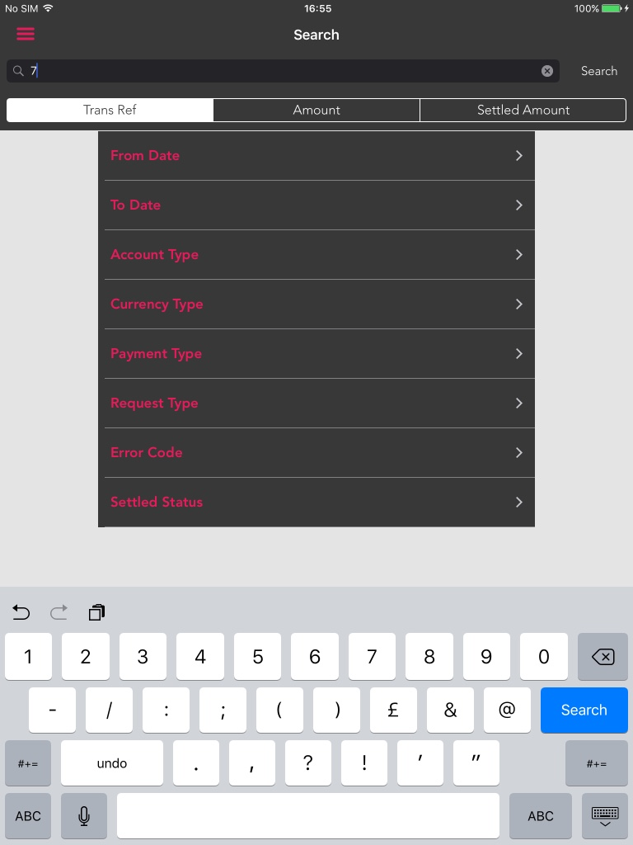

**Figure 24 – Partially Search**

You can either enter a partially or completed transaction number in the search bar then tap the ‘Search’ button either on the keyboard or the button next to the search bar and it will direct you to the Results page – this will be covered in the next section.

|  |  |
| --- | --- |
| C:\Users\mb0137\Documents\FINAL ST ICONS\ST Support Icons-03.png | By clicking either ‘Trans Ref.’, ‘Amount’ or ‘Settled Amount’ the search will be based on that criteria e.g. ‘Trans Ref’ selected searches by Trans Ref. |

## Filters

Filters can be applied to the searches. To apply a filter press on one of the rows in the table below the segmented control.

After you have pressed a row, the row will expand with sub-row(s). The sub-row(s) will affect the results on the search. There are two types of sub-rows, date picker and value picker as shown in the figures below:

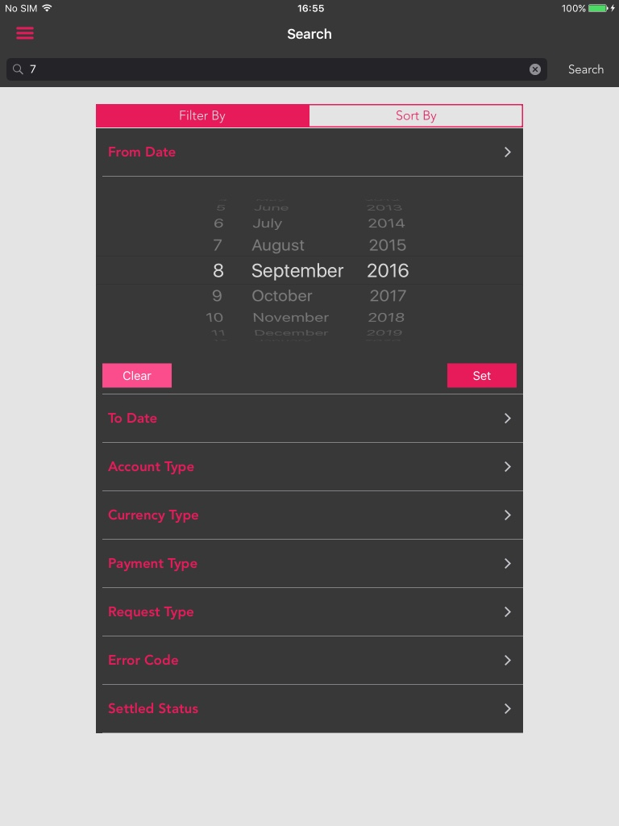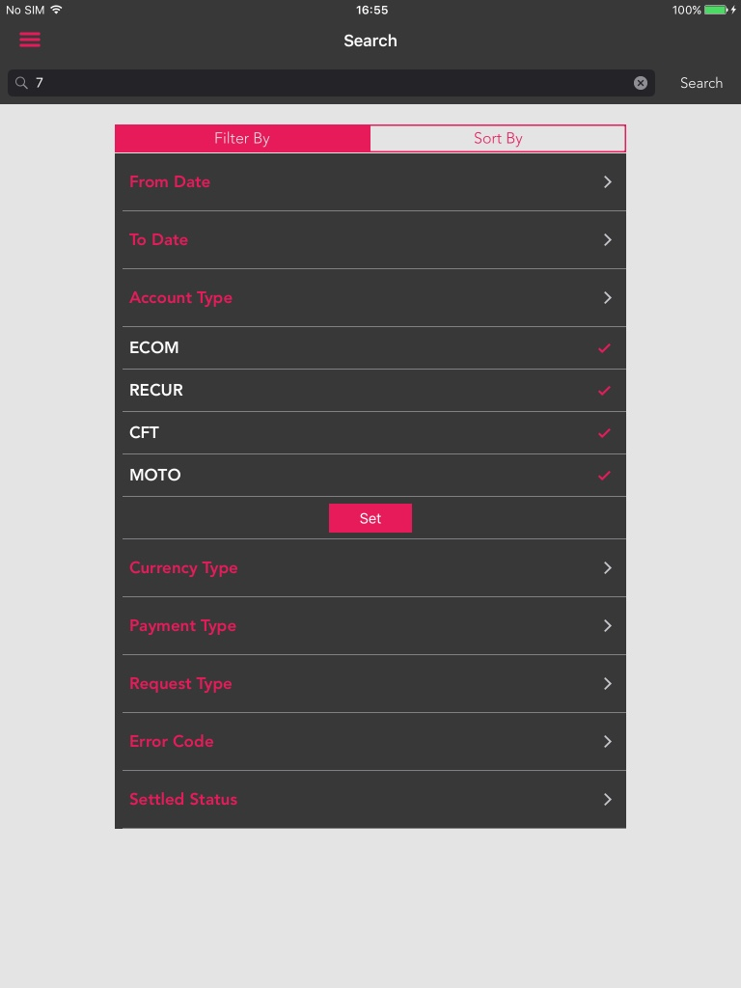

**Figure 25 – Date Picker Figure 26 – Value Picker**

|  |  |
| --- | --- |
| C:\Users\mb0137\Documents\FINAL ST ICONS\ST Support Icons-03.png | A search can take place without a transaction number but a ‘From Date’ and a ‘To Date’ must be provided instead. No default provided. |

### Date Picker

To set a date choose the date in the date picker then press the ‘Set’ button. This will place the set date next to ‘To Date’/ ‘From Date’ (depend on which row that is expanded) and then collapse the sub-rows back into the parent row as shown below:

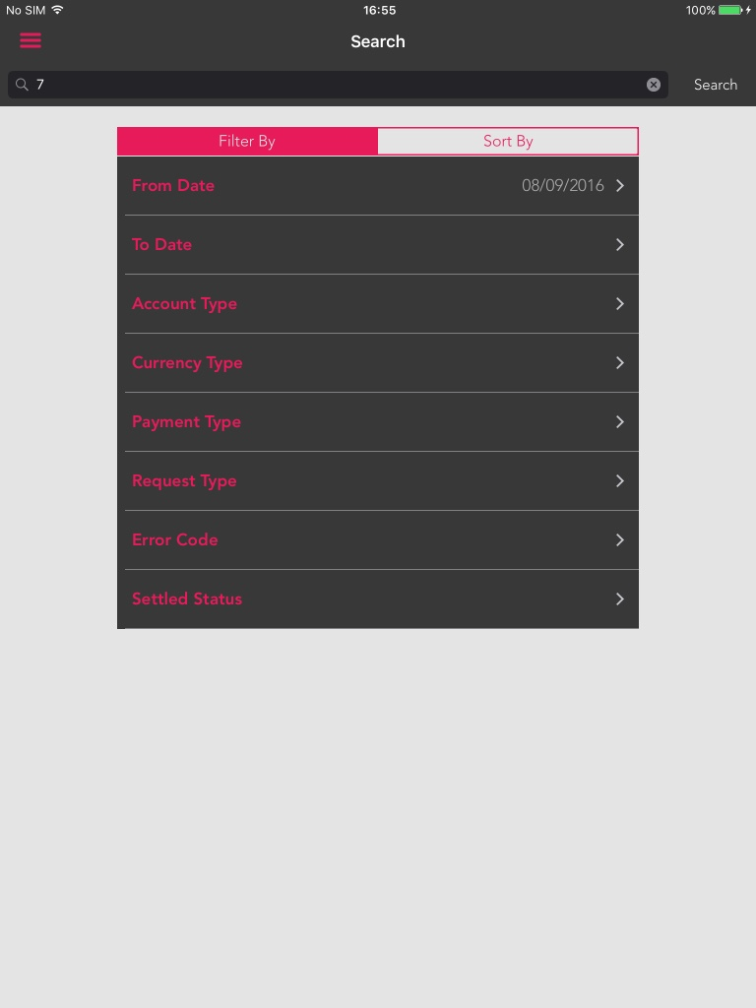

**Figure 27 – Date Set**

|  |  |
| --- | --- |
| C:\Users\mb0137\Documents\FINAL ST ICONS\ST Support Icons-03.png | To remove the set date, expand the row with the date and tap the ‘Clear’ button. This will clear the date and collapse the sub-rows again. |

### Value Picker

To choose values for a specific type tap a row and a checkmark will appear tap it again and the checkmark will disappear.

After selecting the desired values tap either ‘Set’ button or the parent-row and the sub-rows will collapse into the parent row.

|  |  |
| --- | --- |
| C:\Users\mb0137\Documents\FINAL ST ICONS\ST Support Icons-03.png | All checkmarked rows will appear in the results while un-checkmarked will not. |

## Sorts

To apply sorts to the search, tap the ‘Sort By’ segment in the segmented control and a new list of rows will appear as shown below:

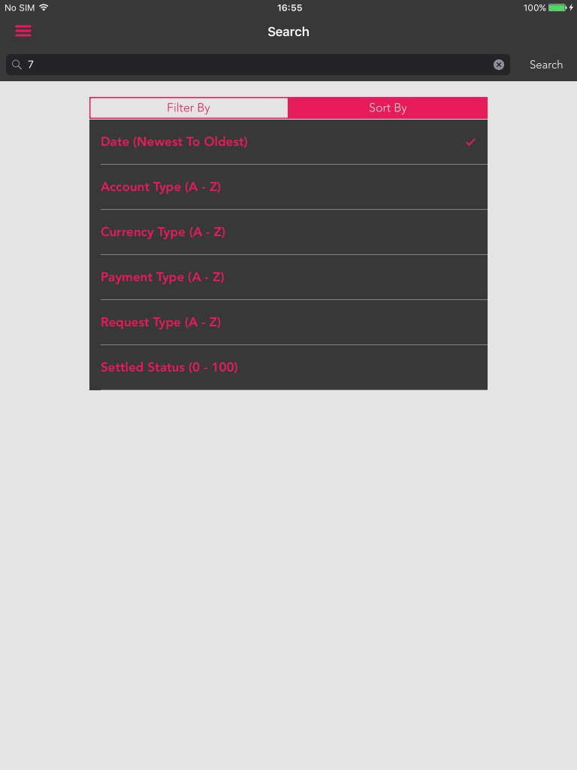

**Figure 28 – Sort By List**

To add or remove a sort tap on the desired row, rows marked with a checkmark will be included into the search while uncheckmarked will not be included.

|  |  |
| --- | --- |
| C:\Users\mb0137\Documents\FINAL ST ICONS\ST Support Icons-03.png | Sort will be applied in the order in which the list is displayed. |

# Results page

After a search has been made, the results page will be displayed as shown below:

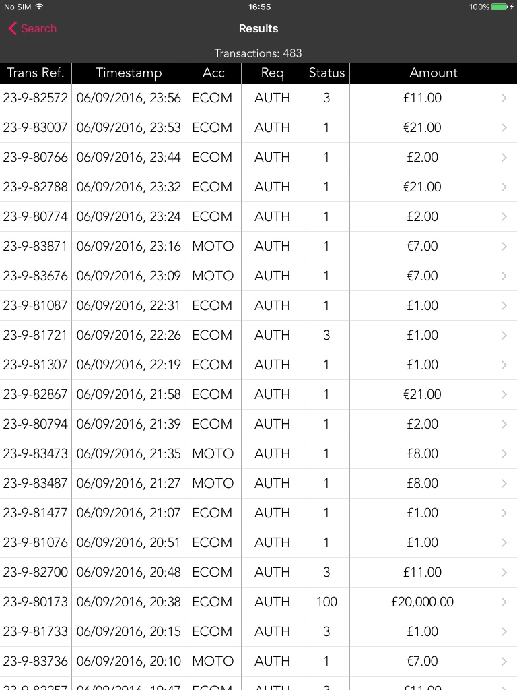

**Figure 29 – Results Page**

|  |  |
| --- | --- |
| C:\Users\mb0137\Documents\FINAL ST ICONS\ST Support Icons-03.png | To return to the search page tap the ‘Back’ button on the top left of the screen. |

## Changing Sorts

To change which sorts that are applied to the results page press one of the column headers e.g. Status which will sort the Settled Status ascending, press again and it will sort descending.

|  |  |
| --- | --- |
| C:\Users\mb0137\Documents\FINAL ST ICONS\ST Support Icons-03.png | When a different sort is pressed previous sorts are cleared. |

## Detailed Result View

### How to display

To get more details on a result tap on the respective row and a popover or view depending on if its an iPad or not will appear with more details on the selected row as shown below:

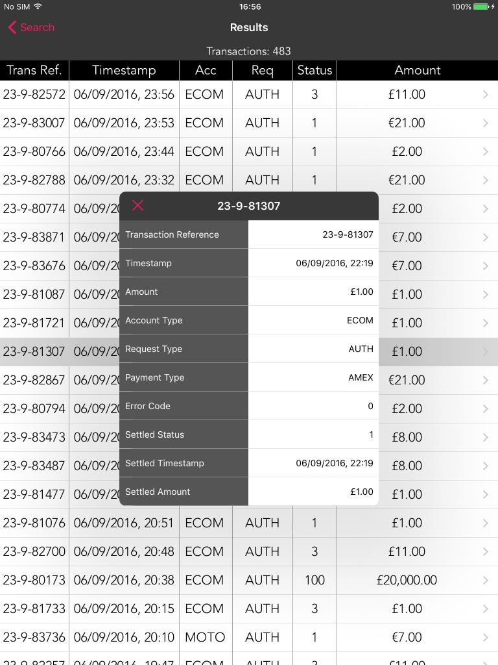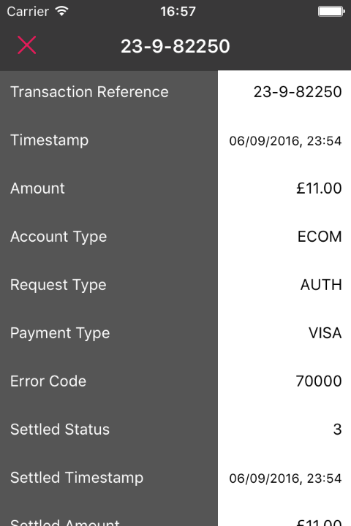

**Figure 30 – iPad detailed page Figure 31 – iDevice detailed page**

|  |  |
| --- | --- |
| C:\Users\mb0137\Documents\FINAL ST ICONS\ST Support Icons-03.png | To return to the result page tap the ‘Dismiss’ button on the top left of the screen. |

### How to copy row entries

To copy a detail from a row making a long press on a specific row and a black ‘Copy’ will appear. Press copy and it will be stored in your clipboard.

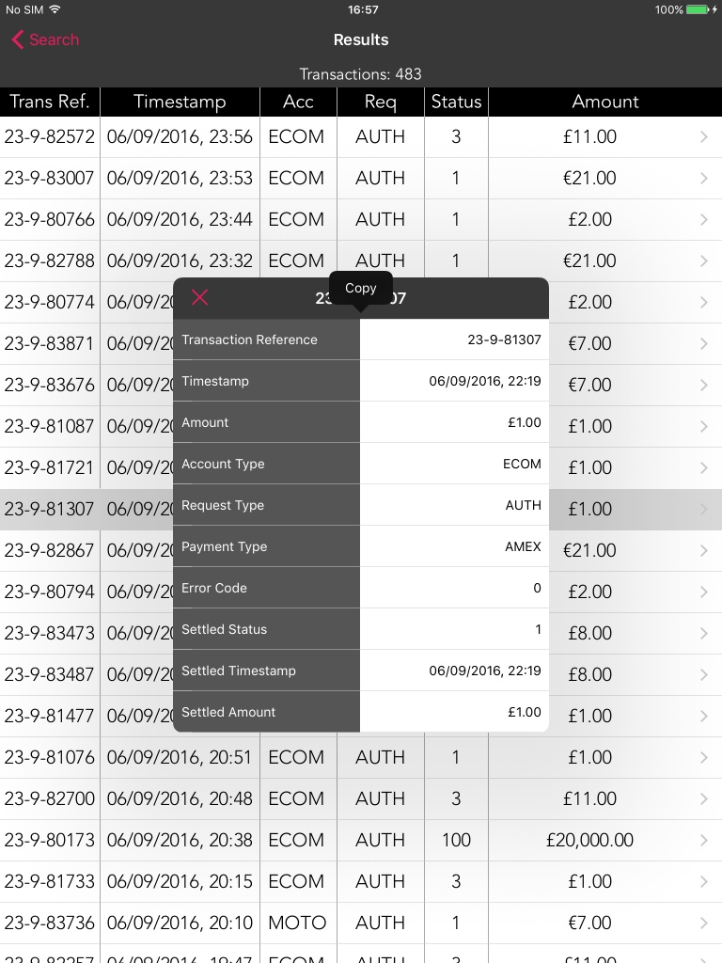

Fi**gure 32 – Copying a row**

# Settings page

# Contact Us page

Navigate to the ‘Contact Us’ page through the use of the reveal menu - details can be found in section **4** **Reveal Menu.**  If done correctly the below page should appear:

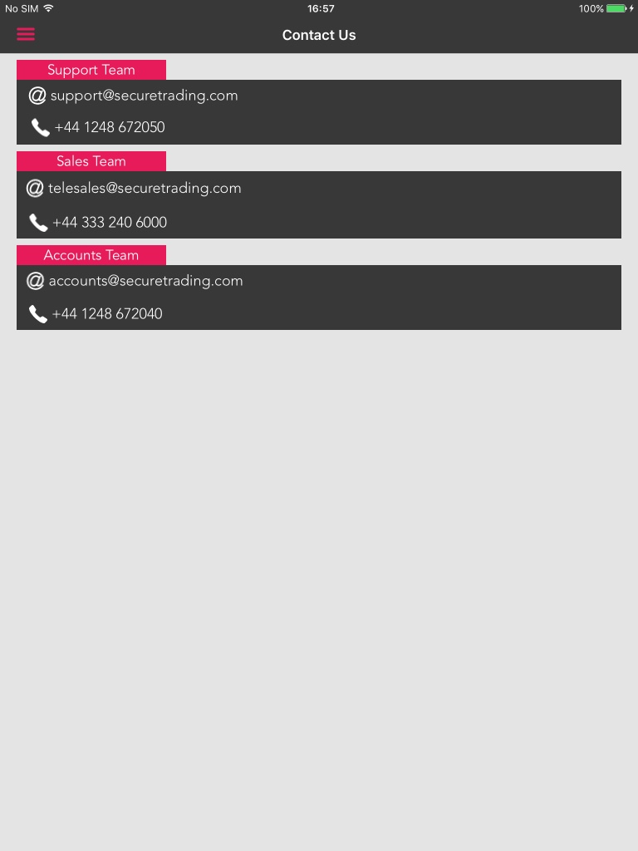

**Figure 33 – Contact Us Page**

## Email

To send an email to either accounts, sales or support team simply tap on the desire email and a popover or an action sheet will appear depending on whether its an iPad or not as shown below:

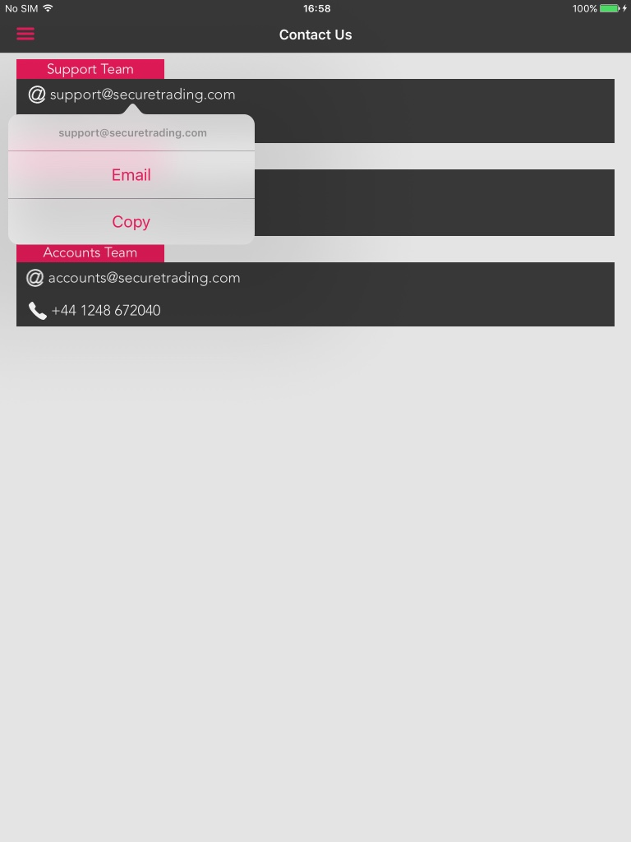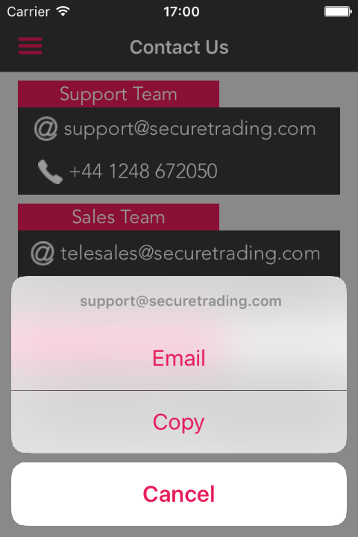

**Figure 34 – iPad Popover Figure 35 – iDevice Popover**

|  |  |
| --- | --- |
| C:\Users\mb0137\Documents\FINAL ST ICONS\ST Support Icons-03.png | To close this view, either tap anywhere outside the view on the iPad, or tap the ‘Cancel’ button on an iDevice. |

After this sheet or view appears, press ‘Send Email’ and the below screen will appear:

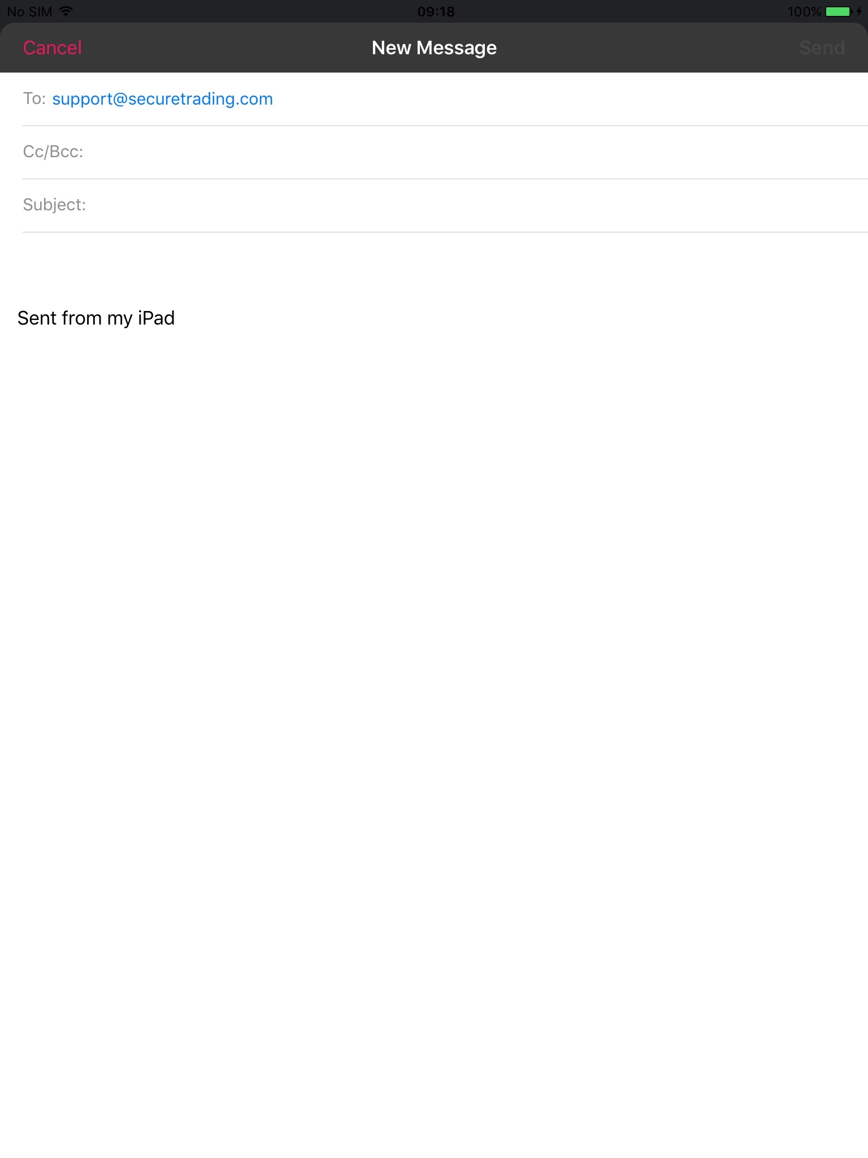

**Figure 36 – Send Email Page**

After finishing with the email tap ‘Send’ and the email will be sent and the device will be returned to the ‘Contact Us’ page.

|  |  |
| --- | --- |
| C:\Users\mb0137\Documents\FINAL ST ICONS\ST Support Icons-03.png | By tapping the ‘Cancel’ button it will give you an option to either save or not save as draft before returning to the ‘Contact Us’ page. |

## Call

To call either accounts, sales or support team simply tap on the desire number and an action sheet will appear depending on whether its an iPad or not as shown below:

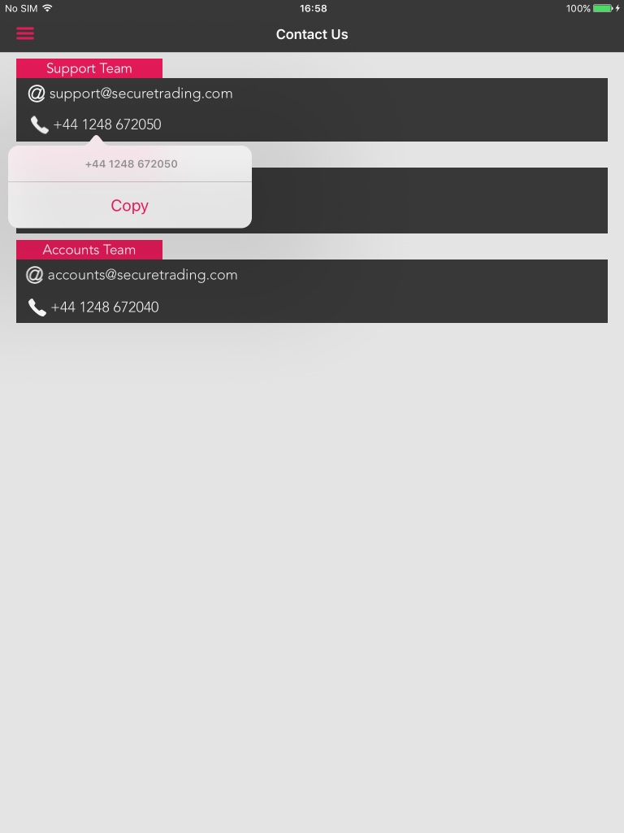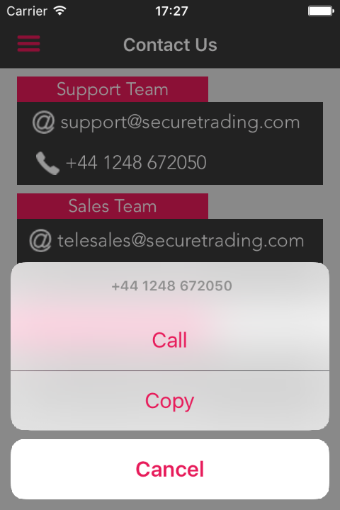

**Figure 37 – iPad Popover Figure 38 – iPhone Alert Sheet**

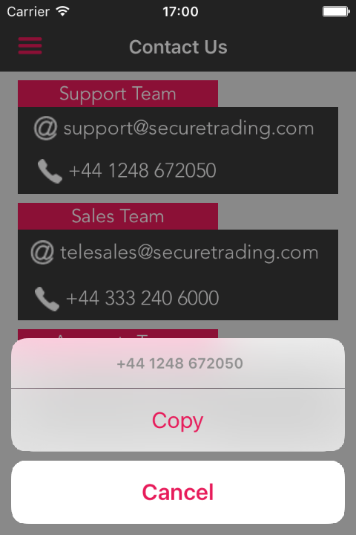

**Figure 39 – iDevice Alert Sheet**

After this view has appeared, tap ‘Call’ and it will begin calling the selected number.

|  |  |
| --- | --- |
| C:\Users\mb0137\Documents\FINAL ST ICONS\ST Support Icons-03.png | As iPhones are the only device capable of making a call, the call button will only be visible on an iPhone. |

## Copy

After you have tapped on either an email or a number it will display a popover or action sheet depending on whether its an iPad or not, as shown below:



**Figure 40 – iPad Popover Figure 41 – iDevice Popover**

Tap ‘Copy’ button and it will copy the tapped detail into your clipboard which can be pasted anywhere inside or outside the app.

# Log Out page

Open the reveal menu as shown in section **4 Reveal Menu** and tap ‘Log Out’. The following alert message will appear:

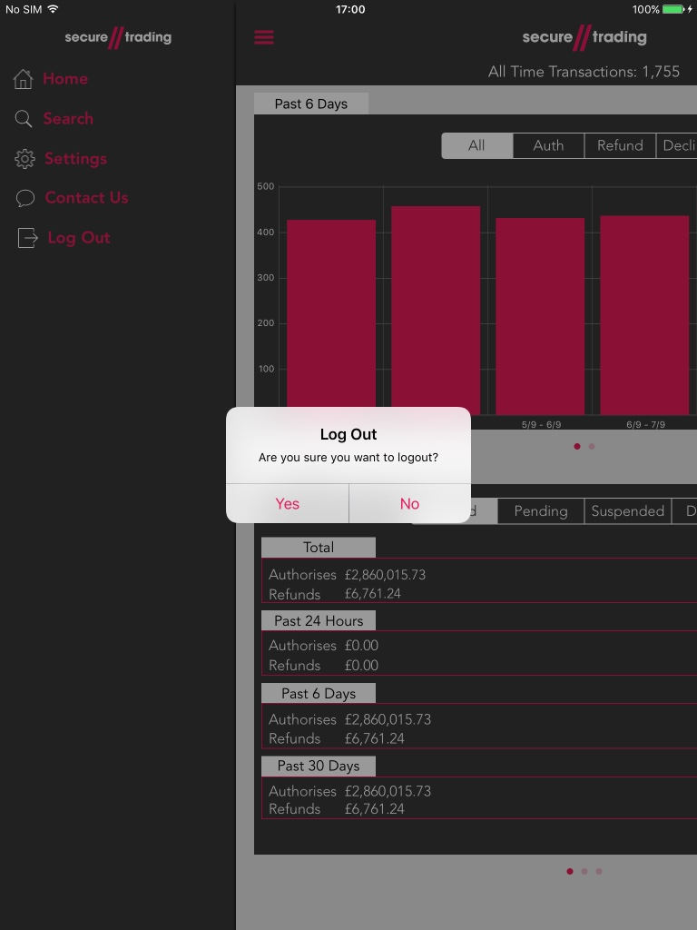

**Figure 42 – Logging out.**

Tap ‘Yes’ and the app will be directed back to the Login page.

|  |  |
| --- | --- |
| C:\Users\mb0137\Documents\FINAL ST ICONS\ST Support Icons-03.png | In the interest of security, it is important to log out of MyST after you have finished administrating your account. |

# Further Information and Support

This section provides useful information with regards to documentation and support for your Secure Trading solution.

## Secure Trading Support

If you have any questions regarding integration or maintenance of the system, please contact our support team using one of the following methods.

|  |  |
| --- | --- |
| Method | Details |
| Telephone | +44 (0) 1248 672 050 |
| Fax | +44 (0) 1248 672 099 |
| Email | [support@securetrading.com](mailto:support@securetrading.com) |
| Website | <http://www.securetrading.com/support/support.html> |

## Secure Trading Sales

If you do not have an account with Secure Trading, please contact our Sales team and they will inform you of the benefits of a Secure Trading account.

|  |  |
| --- | --- |
| Method | Details |
| Telephone | 0800 028 9151 |
| Telephone (Int’l) | +44 (0) 1248 672 070 |
| Fax | +44 (0) 1248 672 079 |
| Email | [sales@securetrading.com](mailto:sales@securetrading.com) |
| Website | <http://www.securetrading.com> |

## Useful Documents

Any other document regarding the STPP system can be found on Secure Trading’s website (<http://www.securetrading.com>). Alternatively, please contact our support team as outlined above.

## Frequently Asked Questions

Please visit the FAQ section on our website (<http://www.securetrading.com/support/faq>).